**Secure Chatting Application with AES Algorithm**

* Secure Chatting Application with AES Algorithm End to End Encryption and Decryption

**Advanced Encryption Standard**

* Advanced Encryption Standard (AES) algorithm is one on the most common and widely symmetric block cipher algorithm used in worldwide.
* This algorithm has an own particular structure to encrypt and decrypt sensitive data and is applied in hardware and software all over the world.
* It is extremely difficult to hackers to get the real data when encrypting by AES algorithm.
* Till date is not any evidence to crake this algorithm. AES has the ability to deal with three different key sizes such as AES 128, 192 and 256 bit and each of this ciphers has 128 bit block size.

**Using**

Javax.Swing

java.net.Socket

java.awt.*;

java.io

**Cryptography and Network Security Algorithms**

Advanced Encryption Standard (AES) Algorithm

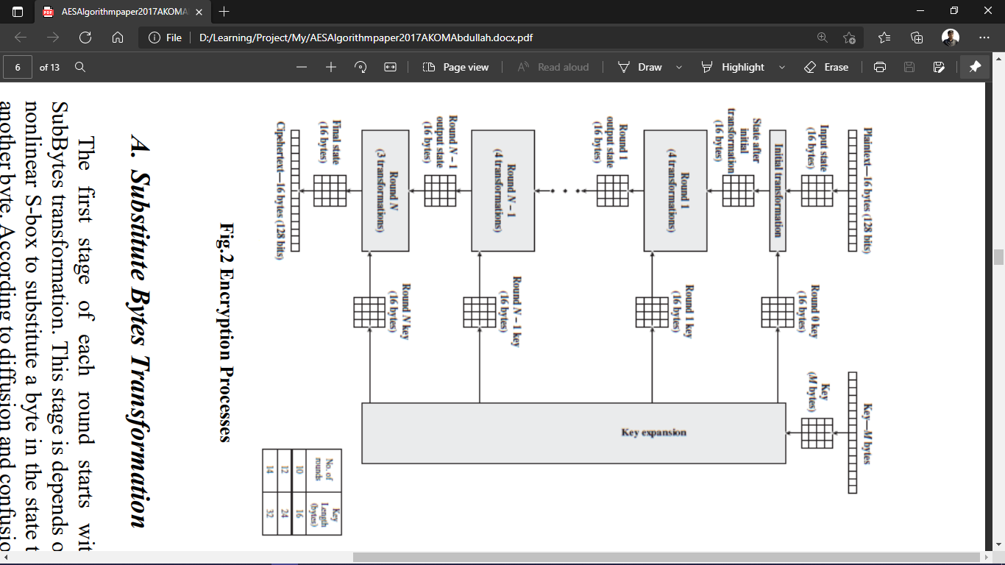

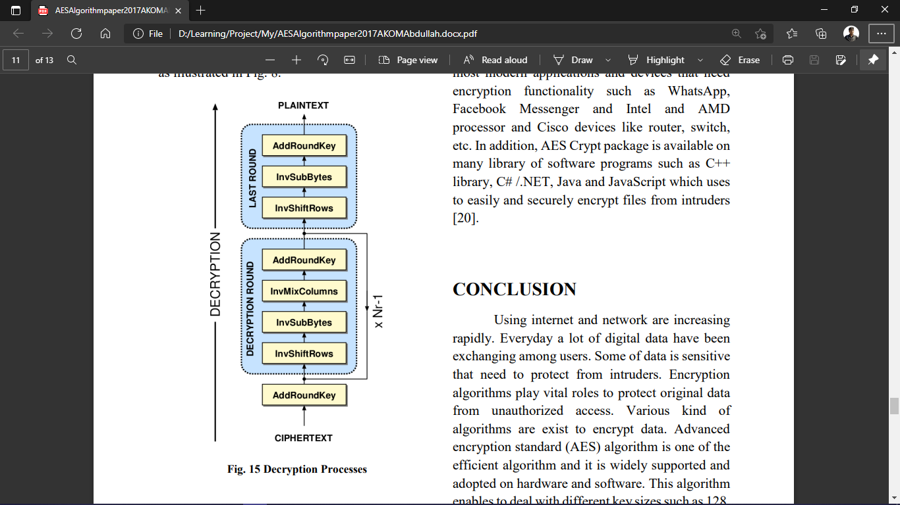

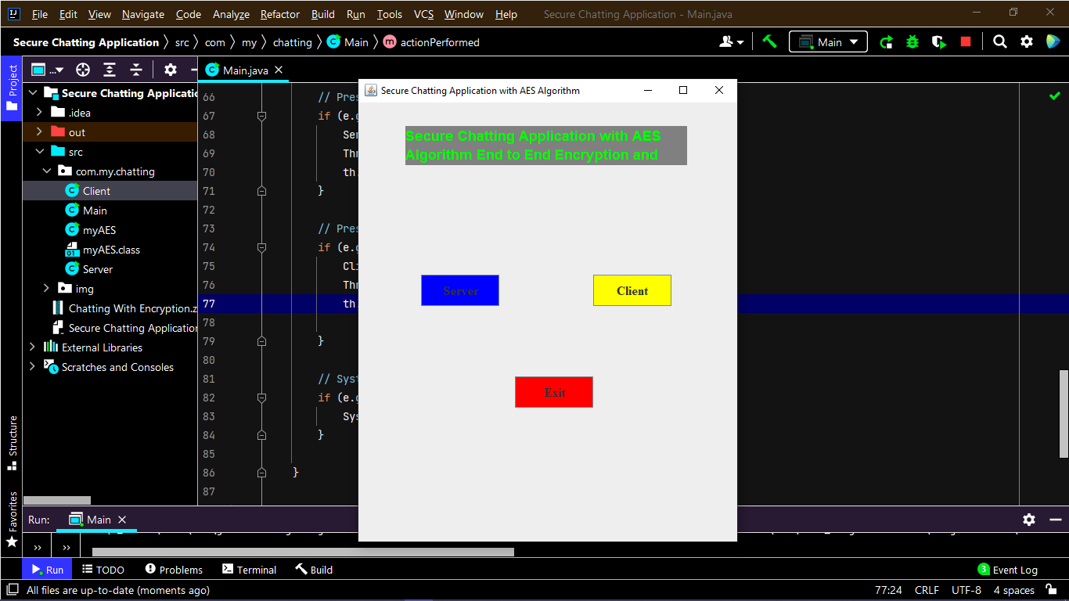

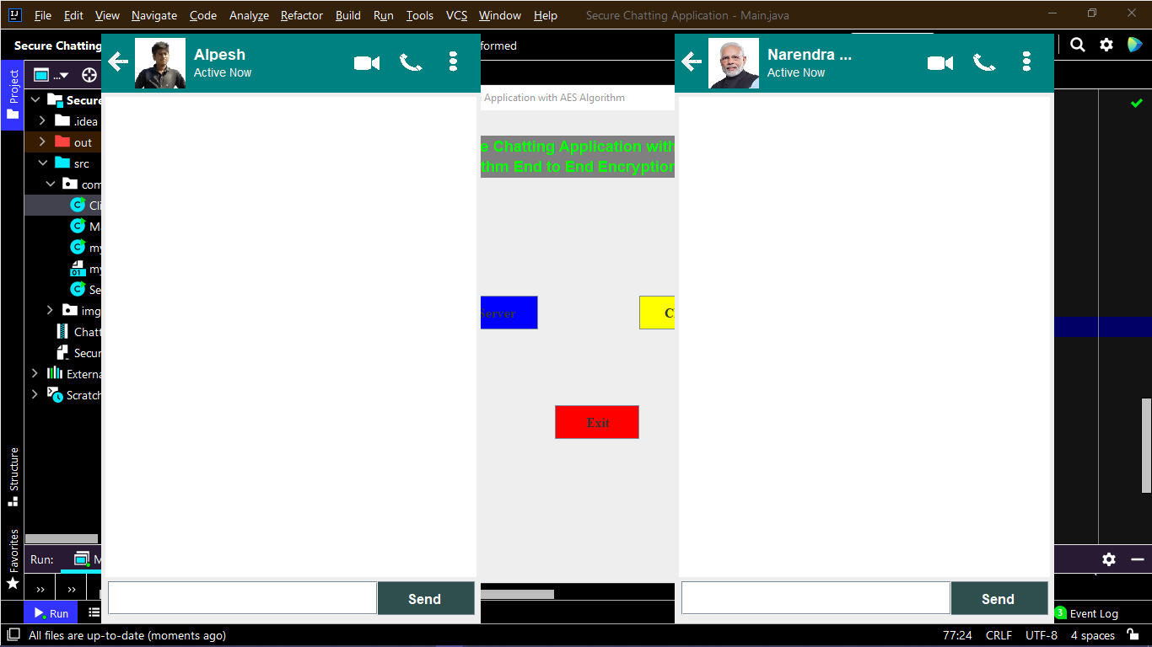

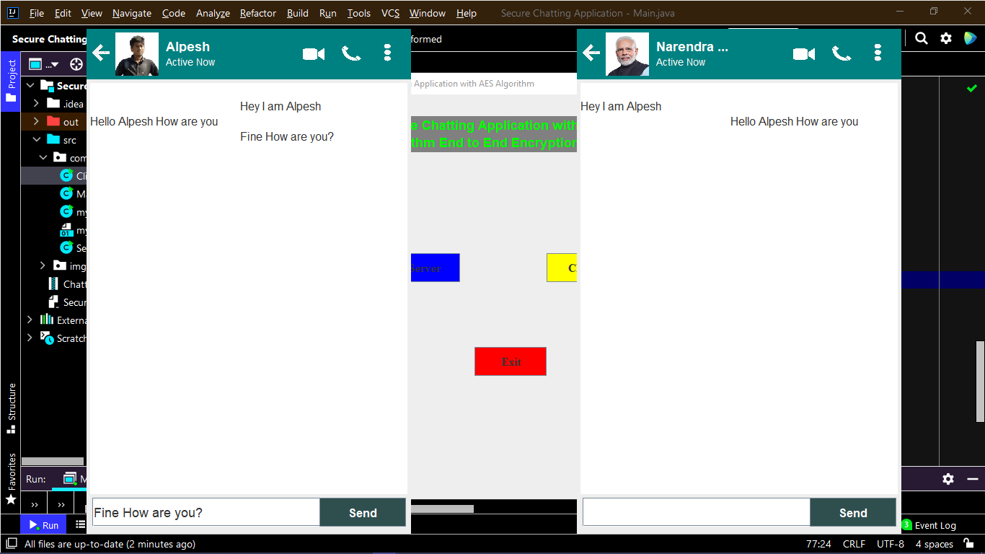

**Reference material Link**

* **AES Algorithm**

*https://drive.google.com/file/d/1RV2lKQqepdJNlYOA8Zm5uopL5SzZaLJT/view?usp=sharing*